YML in Kubernets—

When writing YAML files for Kubernetes, there are four required fields that must be present. APIVersion, Kind, Metadata, and Specifications.

### apiVersion

This field refers to the API, which is being used to create the Kubernetes object being defined. Kubernetes provides various APIs that enable you to create different Kubernetes objects. For example, apiVersion: v1 contains many of the core objects.

apiVersion: v1 is usually considered the first stable release by Kubernetes. Another popular APIVersion is apps/v1,  which adopts objects from v1 and [provides crucial functionality](https://kubernetes.io/docs/reference/generated/kubernetes-api/v1.19/#-strong-api-groups-strong-) such as deployments and ReplicaSets.

Hence, in our YAML file, defining the APIVersion could be:

apiVersion: v1

### kind

kind allows you to specify which type of Kubernetes object you aim to define. The objects that you will specify in this field will be linked to the apiVersion that you specified before since it’s the APIVersion field that enables you to access the different types of objects and their specific definitions. Some of the types of objects that can be defined are pods, services, and DaemonSets.

So, to define a pod object, after specifying the apiVersion, we would specify the kind field as shown below:

apiVersion: v1  
kind: pod

### metadata

After specifying the type of object that’s being defined, the metadata field provides the unique properties for that specific object. This could include the name, uuid, and namespace fields. The values specified for these fields provide us with context for the object, and they can be referred to by other objects. So, this field allows us to specify the identifier properties of the object.

For example, if we are building a spring app, our pod could have the name value shown below:

apiVersion: v1  
kind: Pod

metadata:

    name: spring-pod

### spec

The spec field allows us to define what’s expected from the object that we’re building. It consists of all the key-value pairs specific to defining the operation of the object. Just like the object itself, the specifications of the object depend on the apiVersions specified before. Hence, different APIVersions may include the same object, but the specifications of the object that can be defined will probably differ.

If we continue our example of building the pod object of our spring application, our spec field could resemble what you see below:

apiVersion: v1  
kind: Pod

metadata:

    name: spring-pod

    containers:

    – image: armo/springapp:example

spec:

      name: spring-app

      ports:

      – containerPort: 80

        protocol: TCP

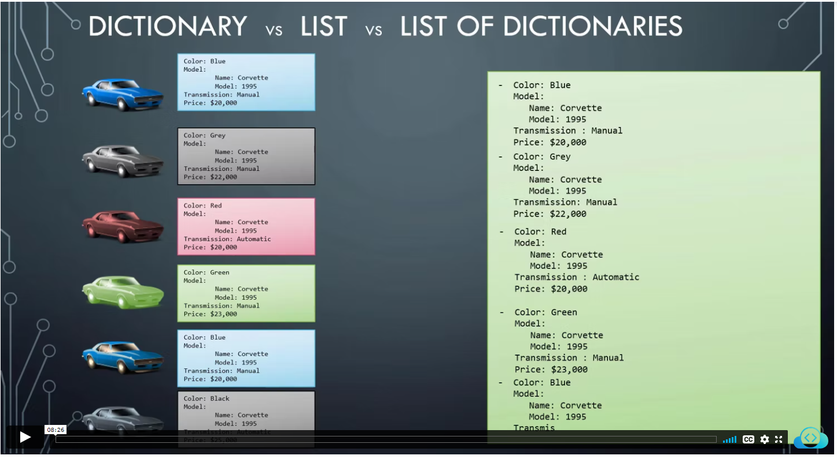

YAML file used to represent configuration data..

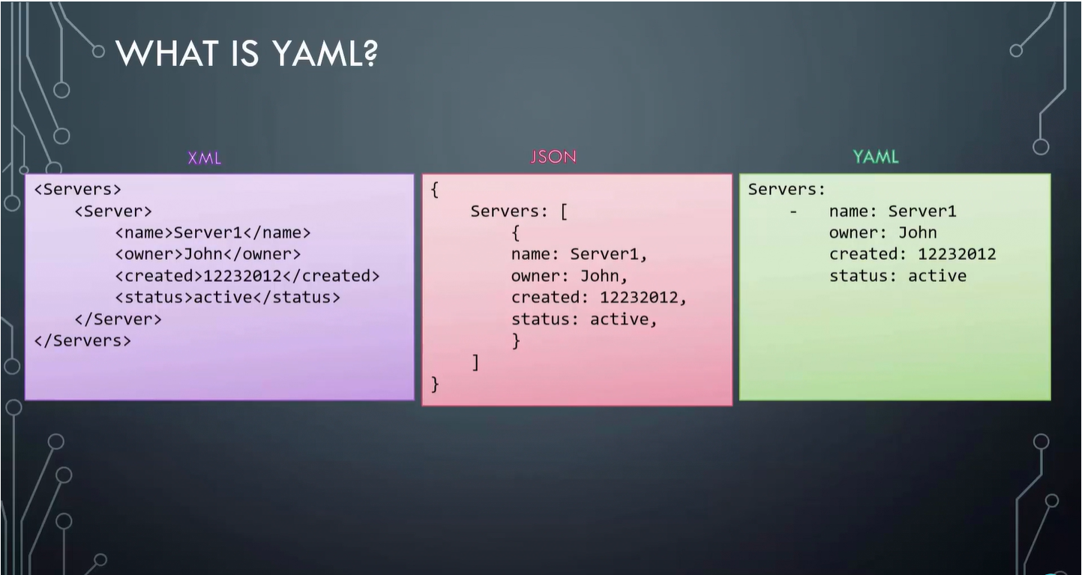

## **Step-02: Create Simple Pod Definition using YAML**

* We are going to create a very basic pod definition
* **02-pod-definition.yml**
* apiVersion: v1 # String
* kind: Pod # String
* metadata: # Dictionary
* name: myapp-pod
* labels: # Dictionary
* app: myapp
* spec:
* containers: # List
* - name: myapp
* image: stacksimplify/kubenginx:1.0.0
* ports:

- containerPort: 80

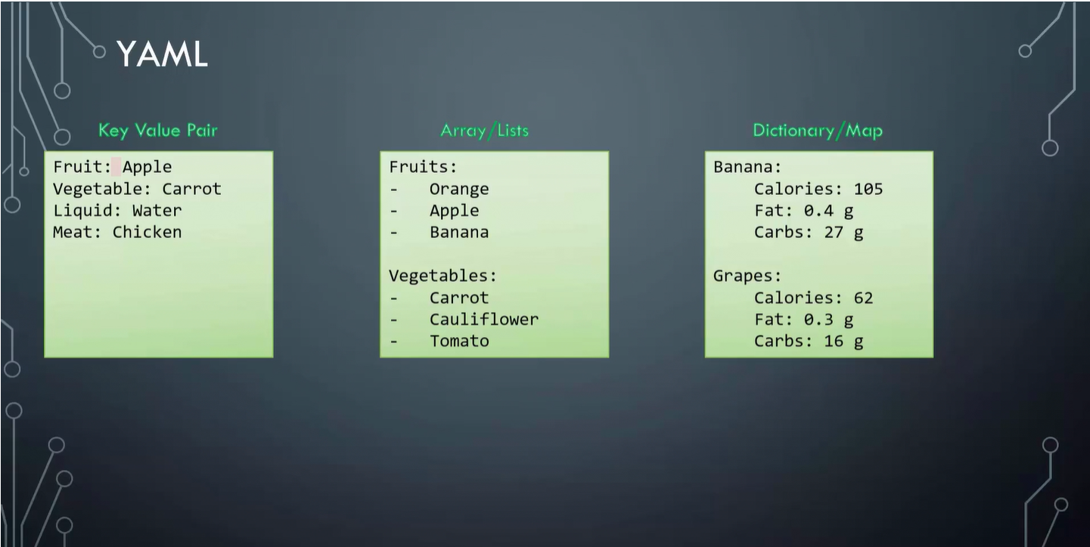

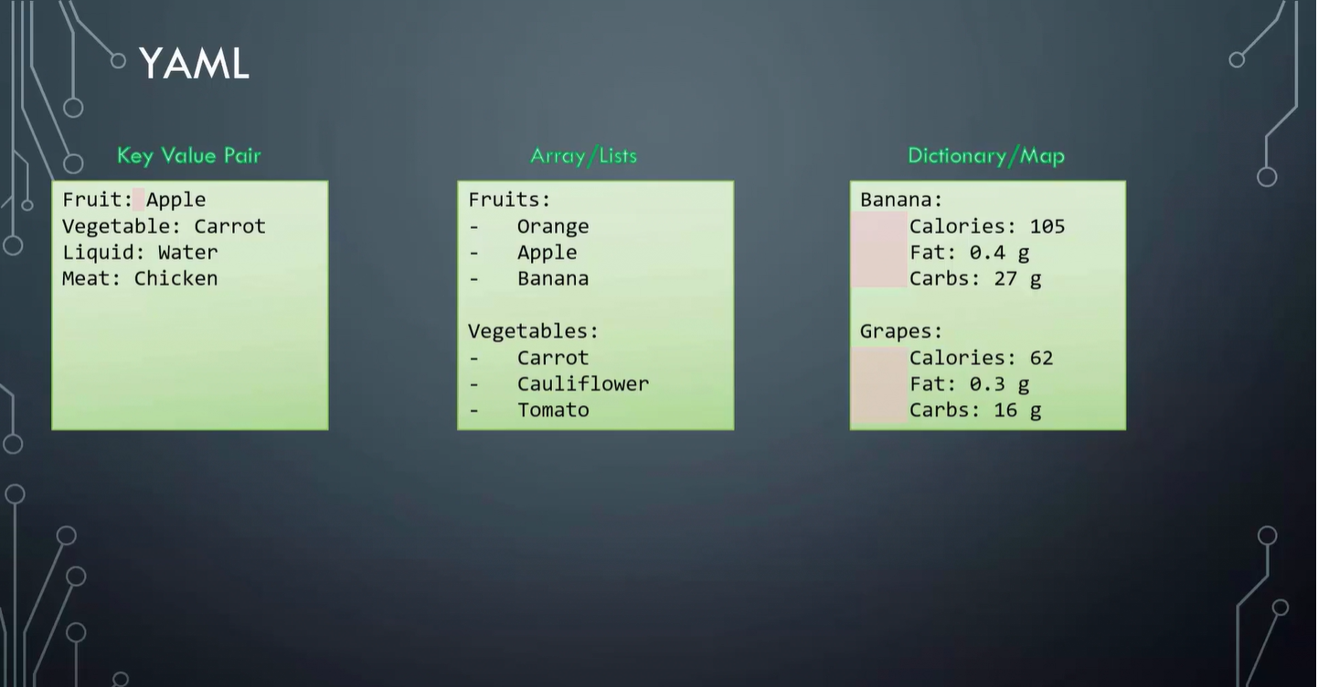

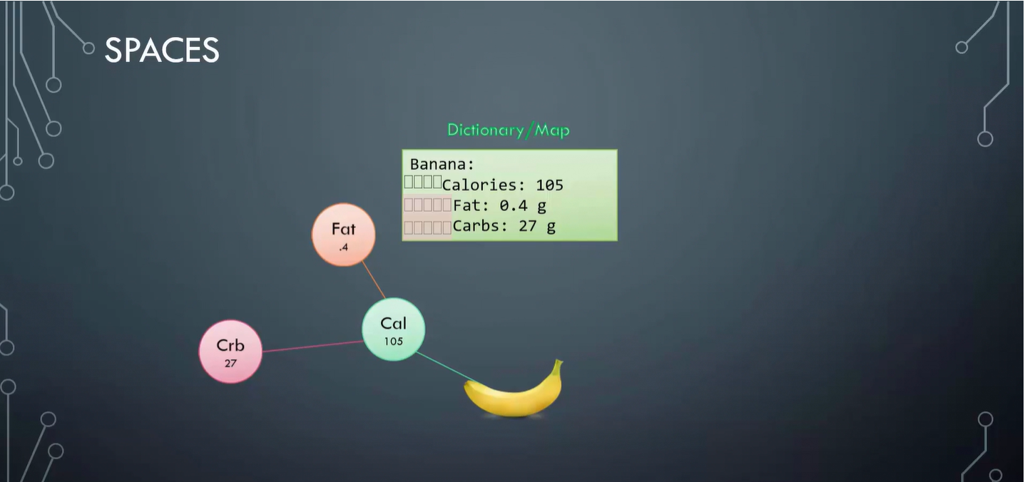

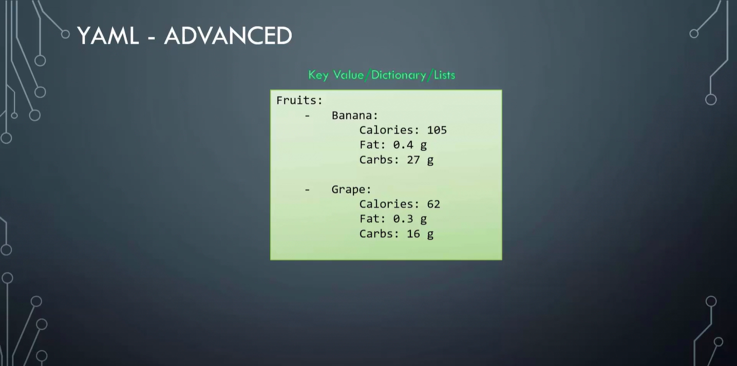

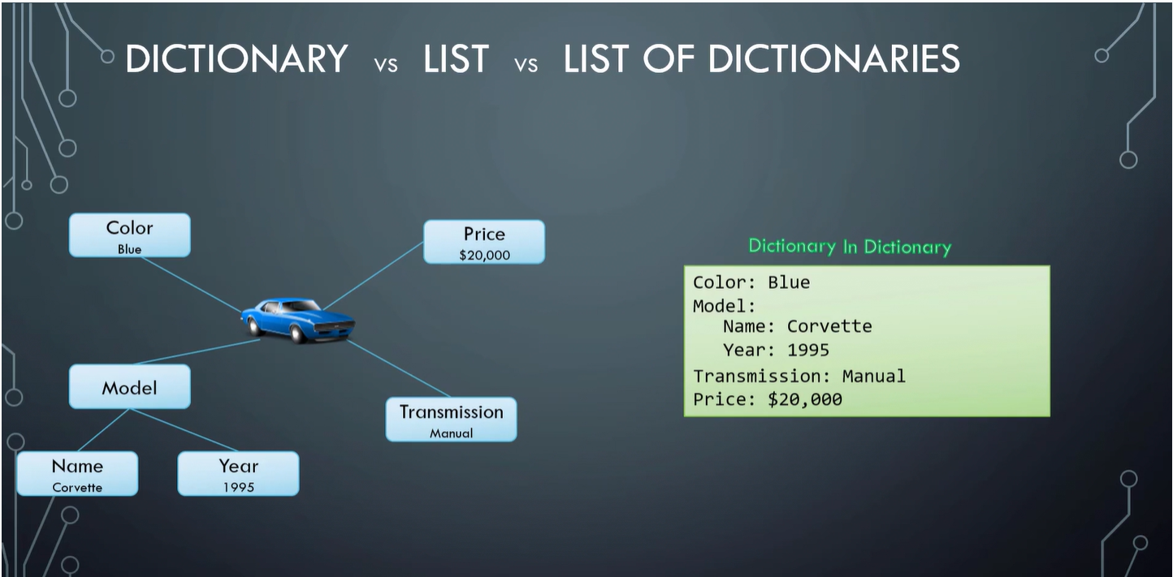

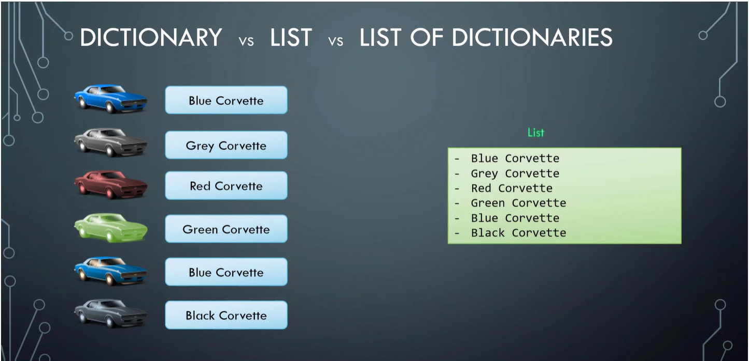

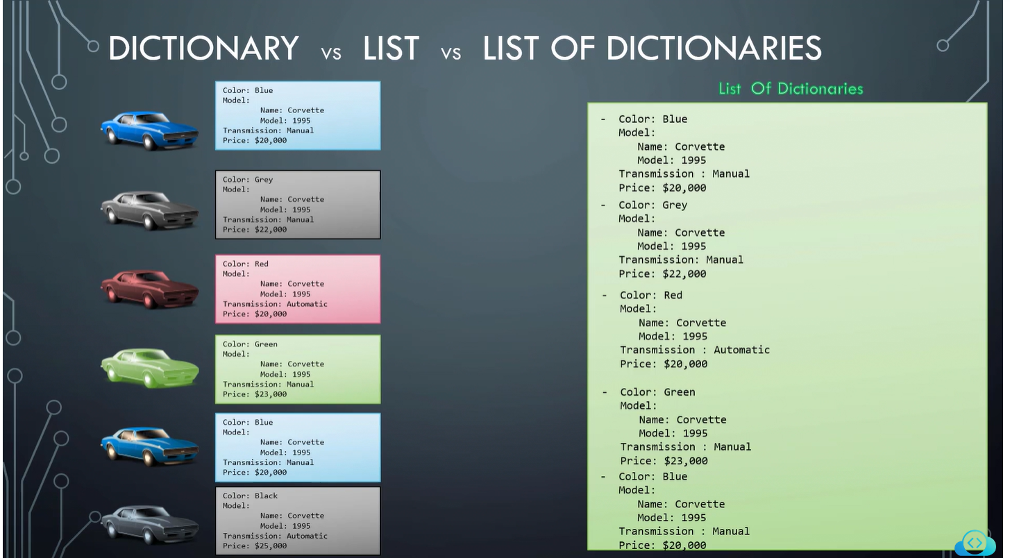

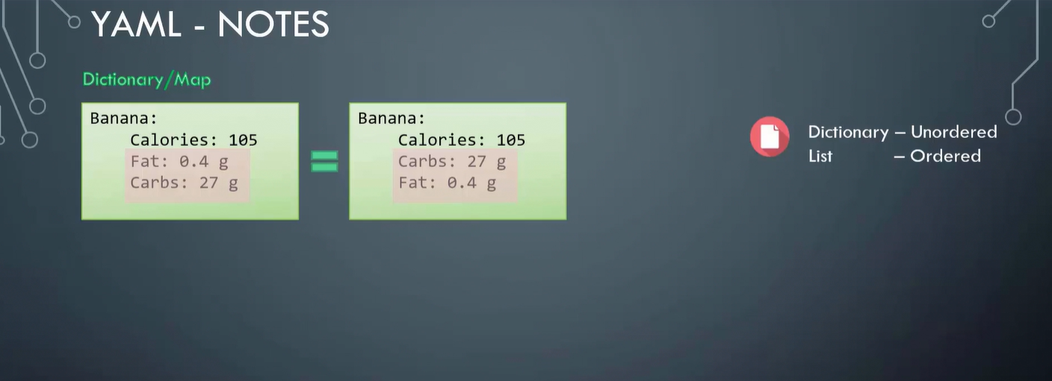

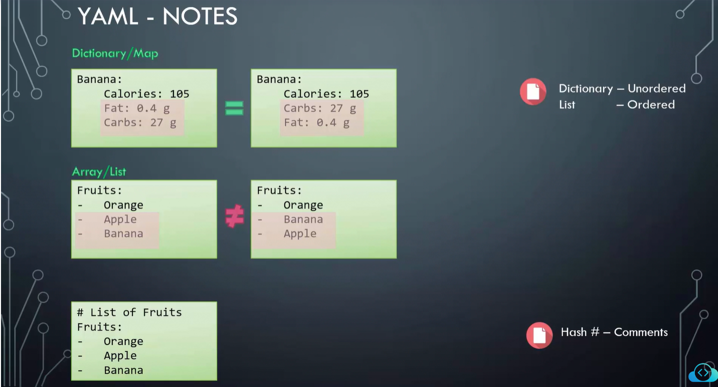

Create Sample YAML file –

[https://kodekloudhub.github.io/yaml-quiz/index.html?_gl=1*1gff71o*_ga*MTA2ODU1MDMxMS4xNjU5NDY1MjI4*_ga_LYL47LCHPW*MTY2NDIxMjgyMC41MS4xLjE2NjQyMTQyNDAuNTkuMC4w*_fplc*WGQzOSUyQmszJTJCNzZRWjFlSzBjOG85Mzk2dWZ6JTJCcSUyQkdrT2c2T1pOZ0FRMGRLVHduaEpMNU4xWnNrNGhvM2RaWCUyRnlkMnlqZ1c0QTFRbHRjNUFvWWpuNVhXbyUyQnplYTVTZ1FVOGQxb09wbXNsMTZRMlJzUmJqWm9heTYlMkZ0azdORWclM0QlM0Q](https://kodekloudhub.github.io/yaml-quiz/index.html?_gl=1*1gff71o*_ga*MTA2ODU1MDMxMS4xNjU5NDY1MjI4*_ga_LYL47LCHPW*MTY2NDIxMjgyMC41MS4xLjE2NjQyMTQyNDAuNTkuMC4w*_fplc*WGQzOSUyQmszJTJCNzZRWjFlSzBjOG85Mzk2dWZ6JTJCcSUyQkdrT2c2T1pOZ0FRMGRLVHduaEpMNU4xWnNrNGhvM2RaWCUyRnlkMnlqZ1c0QTFRbHRjNUFvWWpuNVhXbyUyQnplYTVTZ1FVOGQxb09wbXNsMTZRMlJzUmJqWm9heTYlMkZ0azdORWclM0QlM0Q).

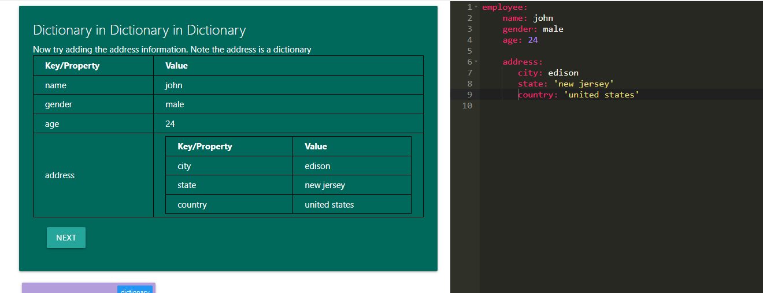

**Kubernetes Concepts – PODs, ReplicaSets, Deployments**

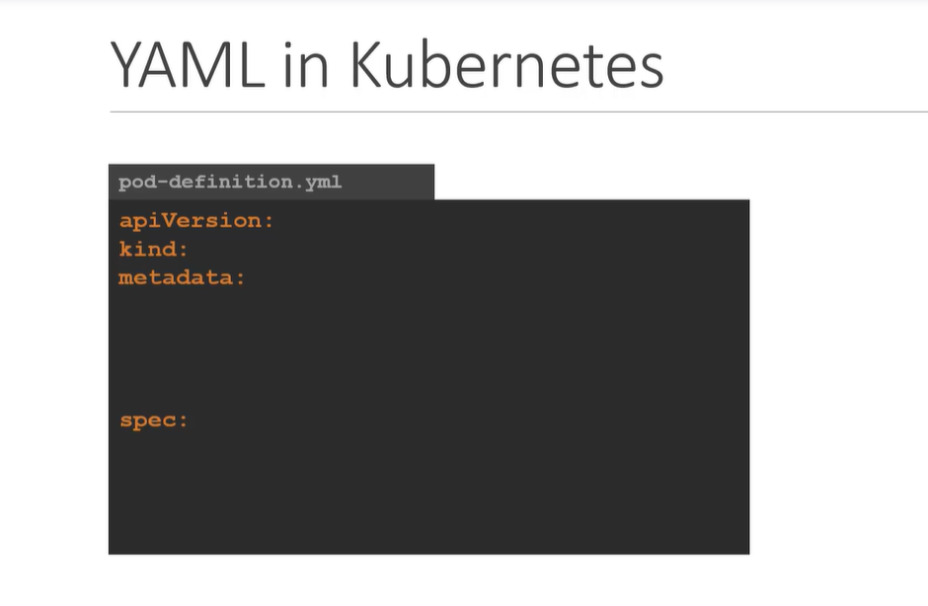

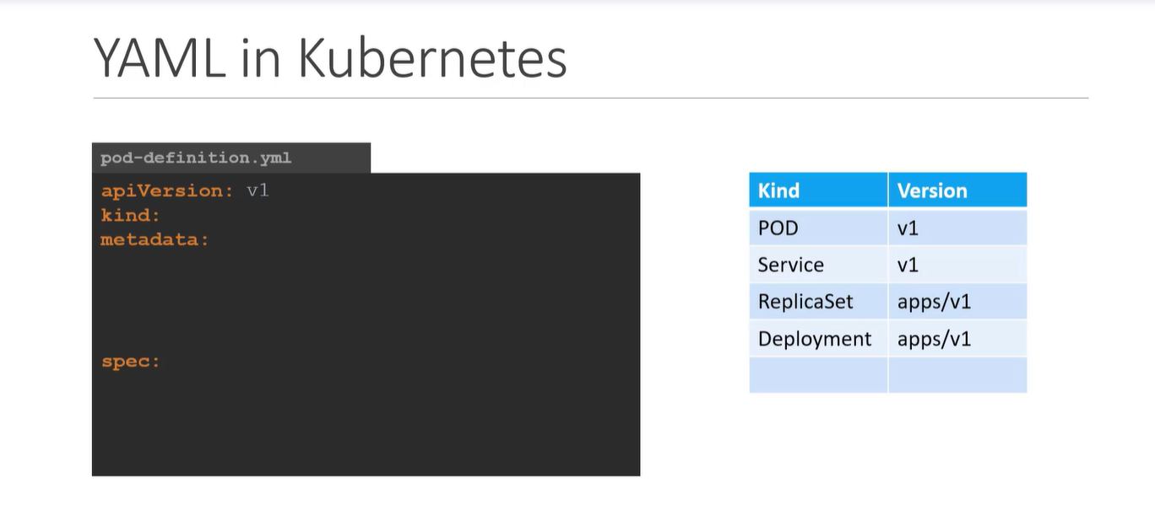

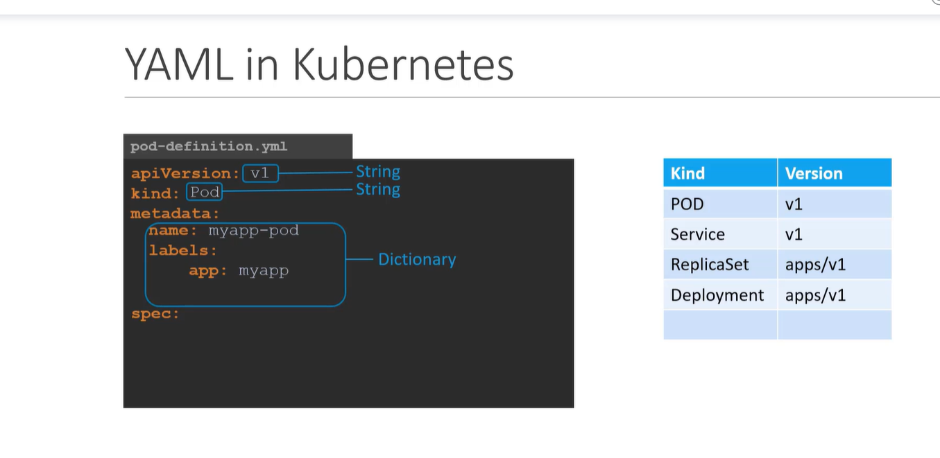

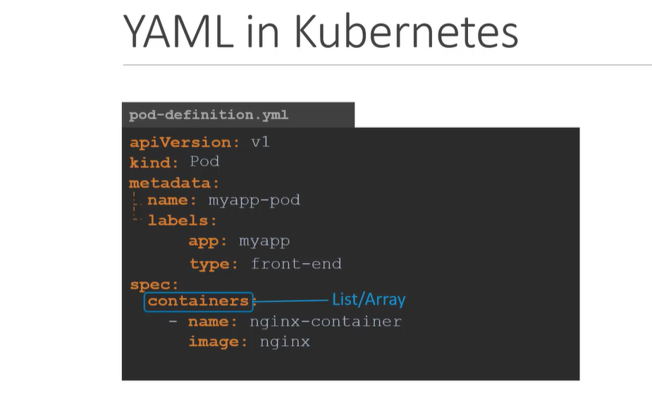

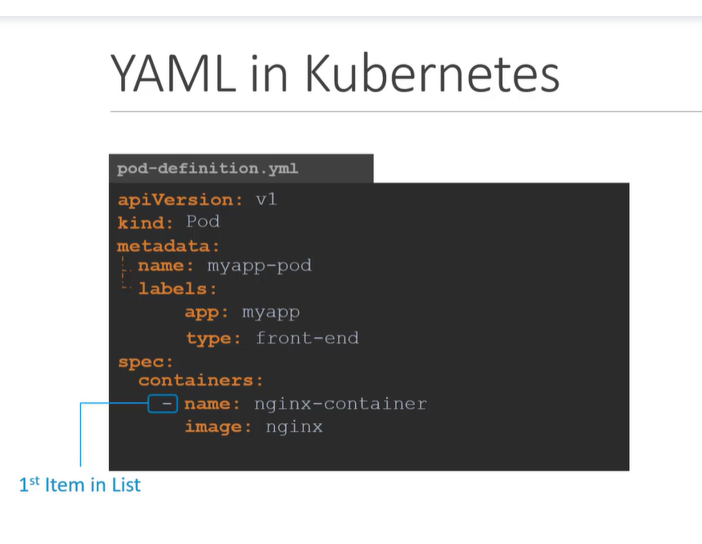

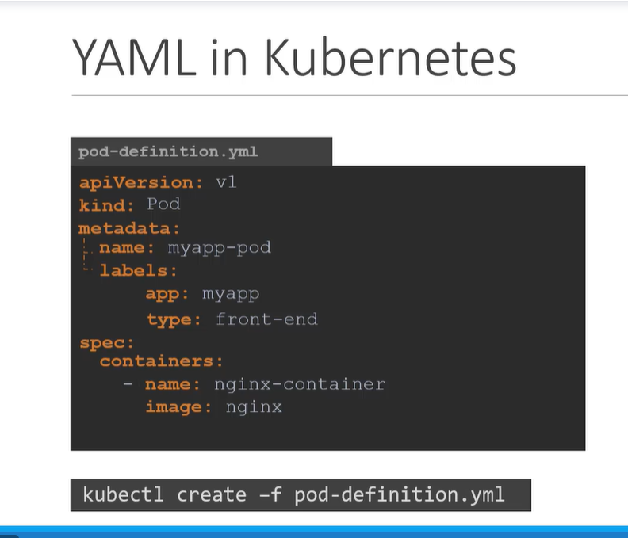

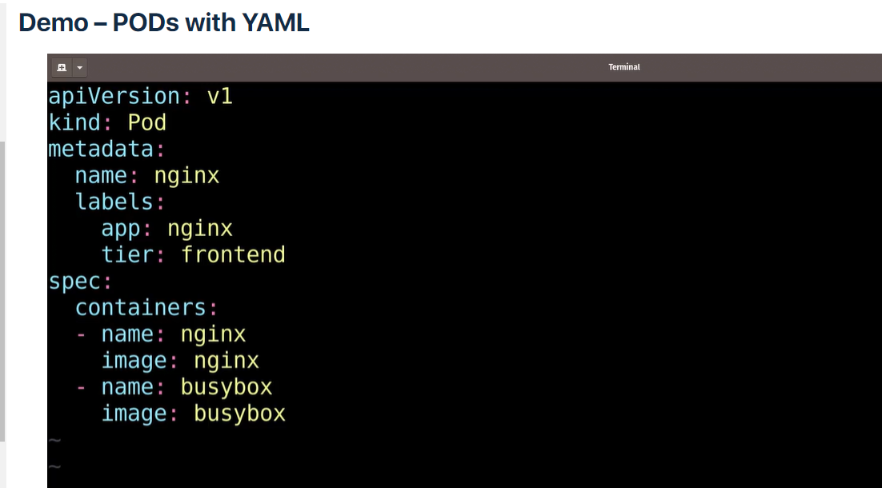

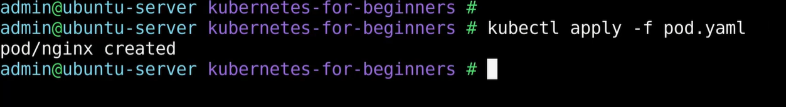

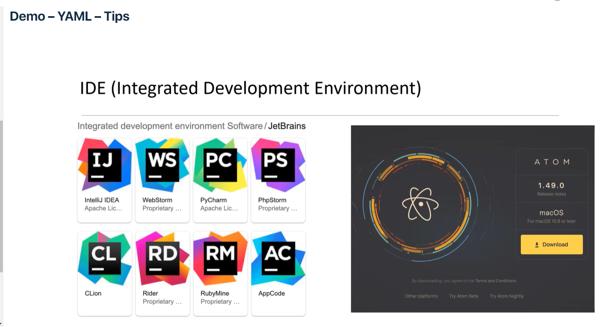

Use vs code for yaml development